A responsive web application to encourage home-cooking and reduce food waste

Preparation and planning

Description and scope

The problem that I am aiming to solve is that of food wastage in the average household. It is estimated that each year 1.3 billion tons of food produced worldwide is wasted, wasting money for the consumer, and increasing the worldwide levels of greenhouse gases (Kirk & Scott, 2018). My solution aims to reduce waste at the consumer level, by encouraging the cooking of ingredients nearing or in some cases just passed their expiration date. It will do this by providing facilities that will enable the user to search for recipes with the ingredients that they have in their fridge that were potentially going to be discarded. The user will also be able to manage an online store cupboard where they can enter items that they would like to be included in these recipes that they may already have stored at home. There is of course a potential risk with any food that is beyond its use-by date, and so the application will also provide some information on food safety to enable the user to make safe decisions about what to eat.

The goal of the project is to deliver a responsive web application that:

* Allows searching of online recipes by ingredient
* Allows viewing of method and ingredients for selected recipe
* Provides information on food safety
* Allows maintenance and viewing of an online store cupboard

The solution that I am proposing is that of a web-based application, that can be used on desktop or mobile devices, due to its responsive nature. I aim to build the application using a JavaScript framework, that I will research and utilise during the course of project. The possible frameworks that I anticipate exploring are React and Vue. I have some previous experience using Angular, and so for this project I would like to gain some new skills and avoid the use of Angular if possible. I also aim to integrate with an 3rd party recipe API to provide the search feature for my application.

By creating my acceptance tests early in the project, I will have a definitive indication of the scope of the project, and what will constitute a complete product. If the application passes these acceptance tests I will know the requirements have been fulfilled and my goals have been met.

Project Tasks and Sub-tasks

|  |  |  |  |  |
| --- | --- | --- | --- | --- |
| **Tasks** | **Sub-Tasks** | **Resources required** | **Skills required** | **Risk** |
| Planning and Design | Read module materials | OU online resources. Little risk of unavailability |  | Time management. |
| Create project plan | Excel has been used, which I have access to on my laptop | Estimating skills for time required for project tasks. Always best to ‘under-promise and over-deliver’ | Under-estimation of time needed for project tasks |
| Complete literature search and review | OU library services and access to online learning resources such as documentation. Should be highly available | Ability to evaluate viability and usefulness of materials for project | Could prove time consuming if a strict timeframe is not set, there are a lot of resources available |
| Discuss and compile requirements | Access to potential users of the application | Requirements gathering and extraction skills | Chosen potential users may not be truly representative of end users, leading to poor requirements |
| Produce and evaluate wireframes | Computer based wireframing tool | Wireframing skills using chosen tool, which I have from previous module studies. | Low risk due to experience of wireframing during previous modules and familiarity with chosen tool. |
| Write acceptance tests | Usefulness to project relies on a thorough and useful set of requirements being gathered from my potential users | Skills on how to write acceptance tests will need refreshing as have not done since level 2 modules. | Carrying this task out early in the process means requirements need to remain fixed for tests to remain meaningful and useful. |
| Set up IDE, development tools and version control | 3rd party provided tools, access to the Internet and a computer | Previous knowledge of development tools that I have used means this should be straightforward | Choosing tools that I am not familiar with could prove costly in time if there is a steep learning curve to use. Can be mitigated to sticking to tools I am familiar with. |
| Carry out responsive design research | Reliable learning sources in this area | Basic CSS and HTML understanding, which has been gained from previous modules. | Time concerns with learning, potential for different methods of achieving desired responsiveness may lead to research overload. Can be mitigated by keeping research as brief as possible and concentrating learning on favoured approach. |
| Carry out JavaScript framework investigation | Reliable learning sources in this area | Understanding of JavaScript and potentially TypeScript, both of which I am familiar with. | Ensuring a sensible amount of time is spent on this aspect of the project I can mitigate this by remaining focussed on a single framework after initial research. |
| Recipe Search | Write HTML, CSS and JavaScript for *Recipe Search* | IDE for development | HTML, CSS and JavaScript | I may need to begin this task before I feel I have researched the new skills required thoroughly enough, due to time constraints. |
| *Recipe Search* testing |  |  | I have no separate testing resource other than myself, so must ensure I do not become blinkered and miss obvious issues. Could include users if possible to carry out testing to mitigate this. |
| Recipe Search refinements |  |  |  |
| *Recipe Search* API integration | Web search engine, thorough and readable documentation provided by 3rd part API provider. API testing software. | Those gathered during TM352 module | There may not exist an API that provides the information that I require for the application, or data may not be in a format that the application can easily consume. Documentation could be lacking in areas I need, or API could become unavailable for some reason. Relies on 3rd party. In this case there is not much I can do to mitigate these risks, and must hope for the best. |
| Recipe Search Results | Write HTML, CSS and JavaScript for *Recipe Search Results* | As above | As above | As above |
| *Recipe Search Results* testing |
| *Recipe Search Results* refinements |
| View Recipe | Write HTML, CSS and JavaScript for *View Recipe* |
| *View Recipe* testing |
| *View Recipe* refinements |
| Add Store Cupboard Item | Write HTML, CSS and JavaScript for *Add Store Cupboard Item* |
| *Add Store Cupboard Item* Testing |
| *Add Store Cupboard Item* Refinements |
| View Store Cupboard Items | Write HTML, CSS and JavaScript for *View Store Cupboard Items* |
| *View Store Cupboard Items* Testing |
| *View Store Cupboard Items* Refinements |
|  | Write HTML, CSS and JavaScript for *Food Safety Index* |
| Testing | Acceptance Testing |  |  | Any shift in requirements will affect this task |
| Cross browser and mobile device testing | Tool that allows emulated testing across multiple browsers | Knowledge of how to operate various types of devices for testing purposes. |  |
| Module tasks | TMA01 |  |  |  |
| TMA02 |  |  |  |
| TMA03 |  |  |  |
| Final project report |  |  |  |

Lifecycle model and schedule

|  |  |  |
| --- | --- | --- |
| **Model** | **Benefits** | **Drawbacks** |
| Waterfall | * A straightforward process that will require less in the way of planning tasks compared to an iterative approach. Each step in the process is only carried out once, rather than having to cycle back a potentially re-plan. * Well suited for smaller software development projects with a small number of stakeholders. | * If requirements change it is hard to accommodate these changes if a phase of the work cycle has already passed. * The process is not very flexible and not very accommodating to changes in scope. * Unsuitable for large software projects due to the fixed nature of the sequence of process steps and inflexibility to change. |
| Iterative waterfall | * More flexible than the standard waterfall approach as steps can be revisited if need be. | * Time consuming in that planning and reviewing can take time away from project implementation. * If not managed correctly this can lead in delays with delivery. Multiple steps backwards to stages in the process can lead to delays |
| Prototyping | * Provides an early idea interface and functionality early in the process, which can aid requirements adjustment if necessary. * Allows early evaluation and feedback of design and functionality early on, meaning delivered product should be closely represent stakeholder requirements. * Can aid in the production of applications with good user experience. * Prototypes encourage discussion between project participants, again aiding requirements gathering. | * Stakeholders can assume the prototype is near to a finished product, leading to unrealistic expectations as to timelines and project outputs. * Prototypes can be time consuming to make depending on their fidelity, adding to project overheads. |

|  |  |  |
| --- | --- | --- |
| **Major Project Risks** | **Likelihood** | **Impact** |
| Learning a new JavaScript framework will take longer than anticipated | M | H |
| Product requirements may change | L | M |
| ‘Feature creep’ may occur as I begin coding and the application will become more complex than I anticipated | L | M |
| Struggles to set up development environment | M | M |
| Falling behind in project schedule | H | H |
| Estimations and scheduling activities carried out for project are not accurate or achievable | L | H |

H = High, M = Medium, L = Low

In deciding upon the lifecycle model that I will use for this project I have considered the potential risks of the project along with a comparison of each model’s benefits and drawbacks. In doing so I have decided on the model that I feel is more appropriate, which is an iterative waterfall approach. I have made this decision as at this stage in planning I feel that the requirements for the application are fairly clear, with not much scope for drastic change, meaning the waterfall approach will be sufficient. I don’t feel the functionality of the application warrants the multiple planning phases that would arise from a fully iterative approach. I have however chosen an iterative waterfall approach as I believe it is imperative to test each new feature as it is developed. I believe this is especially important when testing across device types, as I aim to take a ‘mobile-first’ approach to the CSS, and don’t believe I’ll be able to achieve this without regular testing.

I also believe that the iterative waterfall approach will be beneficial should my identified risks surrounding scheduling and estimating prove a reality. I feel using a truly iterative approach may lead me to become too bogged down in the process, exacerbating these issues.

The initial schedule for my project is shown in the Gantt chart shown in Appendix C. Creating this representation of the schedule has allowed me to visualise the timeline of the project, and to see that I have some slack later in the project should any of the tasks prove more time-consuming that I have estimated.

Resources, skills and methods

The potential group of users for my final product is quite broad as it is not a particularly specialised application, and so as a resource I should be able to access potential users whenever necessary for the project.

I have identified several software resources that I will require access to, and I am sure the list may grow as I settle on the framework that I will use to develop the application.

The primary product that I identified is the IDE that I will use to write the code for the project. I have decided to use Visual Studio Code for this purpose, since I have previous experience using this tool, and I find it very straightforward to operate and achieve the tasks that I need.

I have identified the tool I will use to produce my wireframes, which is Pencil. I have used this program in previous modules and found it easy to navigate and use to produce the desired low fidelity wireframes. I feel that the level of detail that the program offers in respect of wireframe fidelity is adequate for a project of this size.

I have also considered how I will implement version control, and have decided to use Git on this occasion, as again I have some experience with this tool and will not have to spend project time finding an alternative.

The final software product that I am utilising is Trello, which I have used to create a Kanban board to keep my project tasks in order, and to enable me to visualise the progress of the project, and upcoming tasks. I have only added initial TMA tasks to this to help me get organised, and so will need to spend some time updating to encompass the entire project.

Once the investigations into the potential use of a recipe API are underway I envisage that I will need the use of an API testing application, which I have yet to decide upon. I am aware of Postman as a potential candidate, but I will need to research possible options further as the project progresses.

The skills that I am building on during this project are mostly those that I gained during my study of module TM352. One of the main activities I will carry out using the skills I learnt during these studies is to consume a RESTful API. I feel that the module gave me a level of ability in this area which is adequate for this portion of my project work, and so I should not need to expand my skills in this area. I have also gained experience in producing wireframes during this module and I have been able the utilise these skills to begin to create wireframes for this project.

Further skills that I learnt in my studies of TM352 were how to use HTML5, CSS and JavaScript to create interactive web pages. I will expand on these skills mainly into the area or responsive CSS styles, and into the realms of JavaScript frameworks. I have some experience in using the Angular framework to create web applications, and so if I am not able to gain the required skill level in an alternative framework I can utilise these skills and create the application in Angular, although this would not be ideal.

Project work completed

Information sources

As part of my initial project work I have searched for relevant sources, using the OU library and a search engine, that will aid me in the completion of my project. There is a lot of initial research needed before I begin the practical side of my project, and therefore I will need to utilise multiple sources to gain the skills I need. When searching for sources in the OU library I restricted my results to those between 2017 and now, as development practises do change with some frequency, and I didn’t want to be researching using out-dated information.

One source that I have found during my literature search is the book ‘Front-End Reactive Architectures: Explore the Future of the Front-End using Reactive JavaScript Frameworks and Libraries’, Luca Mezzalira (2018). It contains a chapter titled ‘Architectures Comparison’ which provides a timeline and descriptions of various front-end frameworks. The author is a Google Developer Expert which leads me to believe the content of this chapter will be accurate and insightful, and exploring this chapter further will be a good first step in directing me towards the framework that I want to investigate further.

A second source that I have found of interest is ‘Jump Start Responsive Web Design’, Chris Ward (2017). This book provides an in-depth view of many topics concerning responsive design, including what it is, ways in which it can be achieved and code examples of how techniques can be implemented. There are multiple chapters within the book which I envisage will be very useful for me in my research phase, and as a reference while I am implementing code. I can find little information about the author online, but other readers have reviewed the material highly, so I deem it to be a potentially very useful resource.

I have also identified some online documentation at <https://vuejs.org/> and <https://reactjs.org/> that will be extremely useful as I begin to implement code with either of these frameworks. Resources available at these sites include tutorials and coding examples, as well as links to forums where I may find aid if I encounter any issues. I envisage these resources will be extremely useful when it is time for the practical element of my project to begin.

Project work

Due to the nature of my project, and the amount of research and skill development I need to do before I begin to implement code, I have made only small steps in starting the practical work necessary for the project. Beyond the project plan, which has proved extremely beneficial in helping me focus on the project, one initial step that I have taken is to begin to collect requirements by interviewing potential users (Appendix A). These discussions have led me to begin producing low-fidelity wireframes to get an idea of how the requirements that have been identified will be met by the system. So far, I have produced a mobile and desktop sized wireframe for the *Recipe Search* page, and in doing so I have realised I am not very familiar with mobile design best practises, for example how best to show the site menu on a mobile device. I feel that including some research in this area in my schedule would be beneficial to the overall project. The wireframes that I have created so far can be found in Appendix B.

Review and reflection

Reflecting upon the early stages of the project, I think that the main area of concern so far has been time management, and the under-estimation of the work that will be involved in the project. This has led to a late start on the project planning and initial practical work, and I feel some of the early planning stages may have been a bit rushed due to this. This is predominately due to me prioritising work for an already in-progress OU module over the project. Now that I have a schedule in place which also factors in my other module commitments, I sincerely hope this won’t occur going forward, and that the project will be afforded the time needed to complete it on time and to the best of my ability. Saying this, I am on track with the project schedule that I have now created and am feeling enthusiastic and motivated to continue with the project. I am hoping to continue at the working pace that completing the TMA has encouraged me to adopt. I plan to adhere as rigidly as possible to my project plan to ensure that I do not run in to any further time management issues.

Reflecting on the project work that I have carried out so far, I feel that my list of requirements could be expanded somewhat to make the product richer, and so I am inclined to discuss the wireframes I have created with a wider group of potential users to see whether they can be improved or expanded upon. I am aware this could lead to the scope of my project becoming larger, so I will need to contemplate the outcomes before considering implementation. I do intend to get this done as soon as possible so that I can adjust the project schedule if necessary.

My main concern with the upcoming weeks is the additional skills that I need to develop before I get the project underway. I think that I have found some good sources to aid in this skill development, but I think I must be conscious of the point at which I need to stop my research activities and jump in to the practical project work. I need to be aware at all times of the time I have available left for a particular task and move on when necessary.

One activity that I need to be more thorough in is completing my project work diary, as I have found this review and reflection more difficult without rich information in the diary. Going forward I will be more conscious of updating it so that I have plenty of material for the next TMA and final report.

**Word count: 3303**

References

Kirk, A & Scott, P (2018) *The Guardian* [Online]. Available at <https://www.telegraph.co.uk/news/2018/01/02/no-time-leftovers-astonishing-scale-food-waste-uk-around-world/>(Accessed 28 February 2018)

Mezzalira, L. (2018) *Front-End Reactive Architectures: Explore the Future of the Front-End using Reactive JavaScript Frameworks and Libraries,* London, Apress

Ward, C, (2017) *Jump Start Responsive Web Design*, Victoria, SitePoint

Appendix A

Requirements list:

The application should

1. Allow viewing of a virtual store cupboard.
2. Allow the addition of an item to a virtual store cupboard.
3. Allow the deletion of an item from a virtual store cupboard.
4. Add store cupboard ingredients to ingredients list when searching
5. Remove an item or quantity of an item from the store cupboard once it’s been used in a recipe.
6. Allow addition of multiple ingredients to a search a recipe database
7. Display a list of available recipes based on selected ingredients
8. Allow sorting and filtering of recipes
9. Show method and ingredients list of a selected recipe
10. Provide information about food safety

Appendix B

Wireframes for Recipe search mobile and desktop view

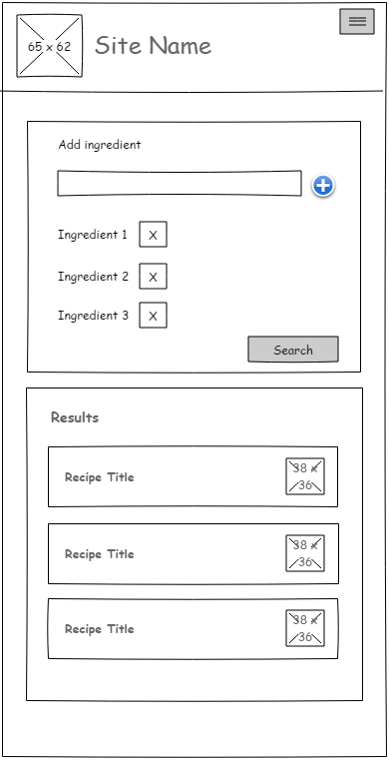

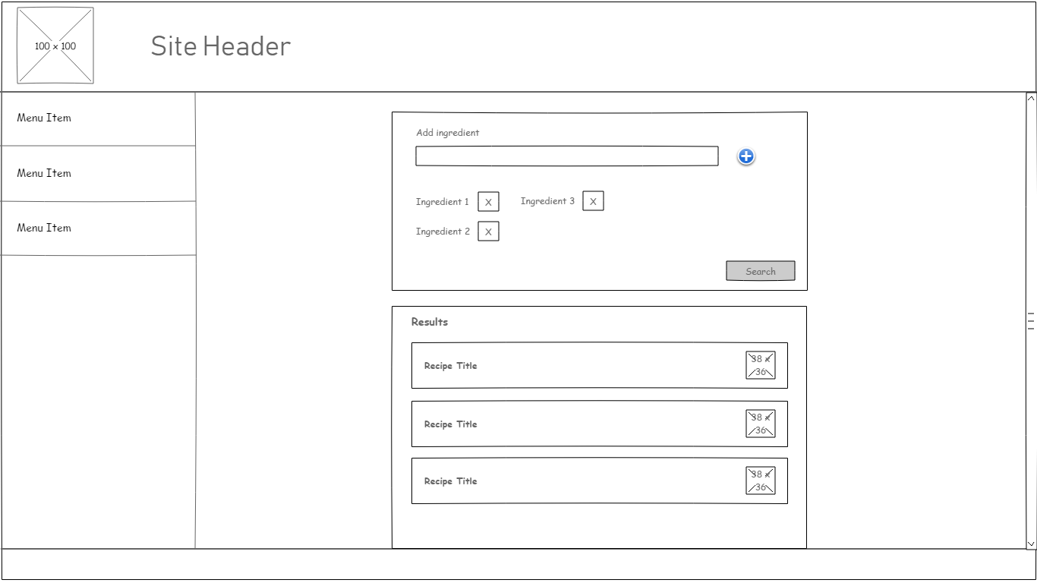

Appendix C

Project schedule Gantt chart

